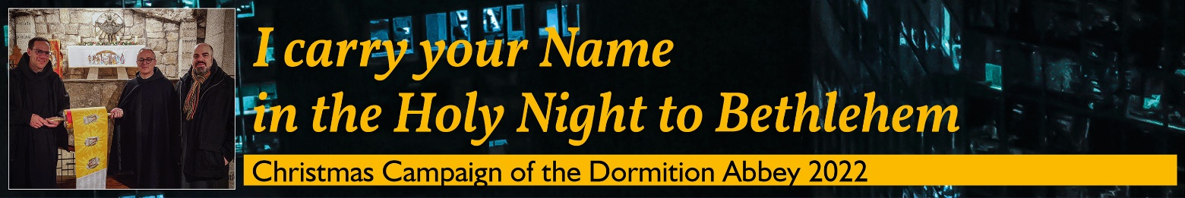

Please, send this list before 21st December 2022
Dormition Abbey – Christmas Campaign - P.O.B. 22 – 9100001 Jerusalem/ISRAEL
(Please, consider that sending by mail to Israel may take some weeks!)
or via email: Weihnachtsaktion@Dormitio.net

Nr. | First Name and Family Name | Email-Address

