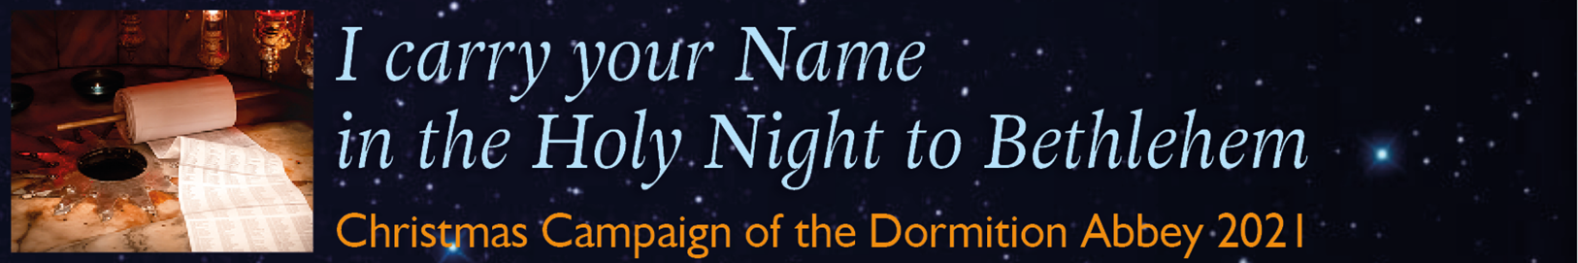

Please send this list before 20th December 2021
Dormition Abbey – Christmas Campaign - P.O.B. 22 – 9100001 Jerusalem/ISRAEL
(Please consider that sending by mail to Israel may take some weeks!)
or via fax: +972 2 5655 337
or via email: Weihnachtsaktion@Dormitio.net

Nr. | First and Family Name | Email-Adresse

