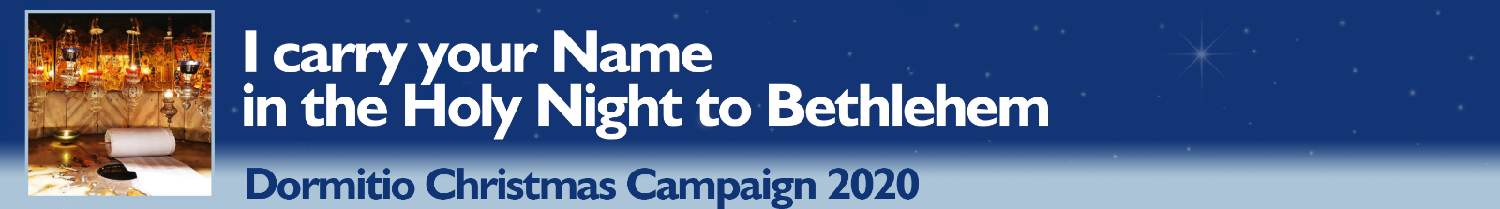

Please send this list before 19th December 2020
Dormition Abbey – Christmas Campaign - P.O.B. 22 – 9100001 Jerusalem/ISRAEL
(Please consider that sending by mail to Israel may take some days!)
or via fax: +972 2 5655 332
or via email: Weihnachtsaktion@Dormitio.net

Nr. | First and Family Name | Email-Adresse

